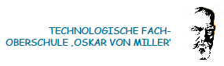


LERNBERATER/INNEN 2016-17

AG-Leiterin: Gabriella Piazzi

RG |  |  | TFO
1ARG | Gabriela Piazzi |  | 1ATFO | Josef Prantl
1BRG | Beate Riffeser |  | 1BTFO | Josef Prantl
1CRG | Klaus Refle |  | 1CTFO | Eva Maria Pletz
1DNW | Vanessa Da Pozzo |  | 1DTFO | Astrid Resch
2ARG | Klaus Refle |  | 2ATFO | Vanessa Da Pozzo
2BRG | Gabriela Piazzi |  | 2BTFO | Marco Aliprandini
2CRG | Petra Waldner |  | 2CTFO | Vanessa Da Pozzo
2DNW | Eva Maria Pletz |  | 2DTFO | Astrid Resch
2ERG | Sandra Piscitelli |  | 3ABW | Astrid Resch
3ARG | Petra Waldner |  | 3BBW | Hildegard Pircher
3BRG | Gabriela Piazzi |  | 4ABW | Marco Aliprandini
3CRG | Klaus Refle |  | 5ABW | Marco Aliprandini
3DNW | Helga Verena Linter |  | 3AEL | Heidi Maffei
4ARG | Gabriela Piazzi |  | 3BEL | Heidi Maffei
4BRG | Sandra Piscitelli |  | 4AEL | Daniele Seppi
4CRG | Gabriela Piazzi |  | 4BEL | Hildegard Pircher
4DNW | Daniele Seppi |  | 5AEL | Daniele Seppi
5ARG |  |  | 5BEL | Vanessa Da Pozzo
5BRG
5CRG | Gabriela Piazzi
5DNW | Helga Verena Linter

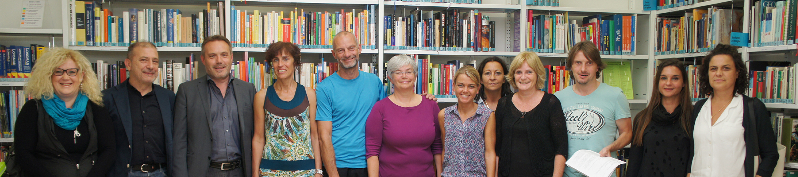

v.l. Heidi Maffei, Marco Aliprandini, Josef Prantl, Astrid Resch, Klaus Refle, Petra Waldner, Beate Riffeser, Helga Verena Linter, Gabriela Piazzi, Daniele Seppi, Vanessa Da Pozzo, Hildegard Pircher (Koordinatorin Inklusion). Im Bild fehlen Sandra Piscitelli, Eva Maria Pletz

